Experiment 8: Edge Detection using Sobel and Canny Operators

Aim

To study and implement edge detection using Sobel and Canny operators.

Algorithm:

Load the input image.

Convert to grayscale.

Apply Sobel operator for gradient detection.

Apply Canny operator for edge detection.

Display results.
Program:
import cv2
import matplotlib.pyplot as plt
image = cv2.imread('sample.jpg', 0)
# Sobel Edge Detection
sobelx = cv2.Sobel(image, cv2.CV_64F, 1, 0, ksize=5)
sobely = cv2.Sobel(image, cv2.CV_64F, 0, 1, ksize=5)
# Canny Edge Detection
canny_edges = cv2.Canny(image, 100, 200)
plt.subplot(1,3,1), plt.imshow(image, cmap='gray'), plt.title('Original')
plt.subplot(1,3,2), plt.imshow(sobelx+sobely, cmap='gray'), plt.title('Sobel')
plt.subplot(1,3,3), plt.imshow(canny_edges, cmap='gray'), plt.title('Canny')
plt.show()

Output:

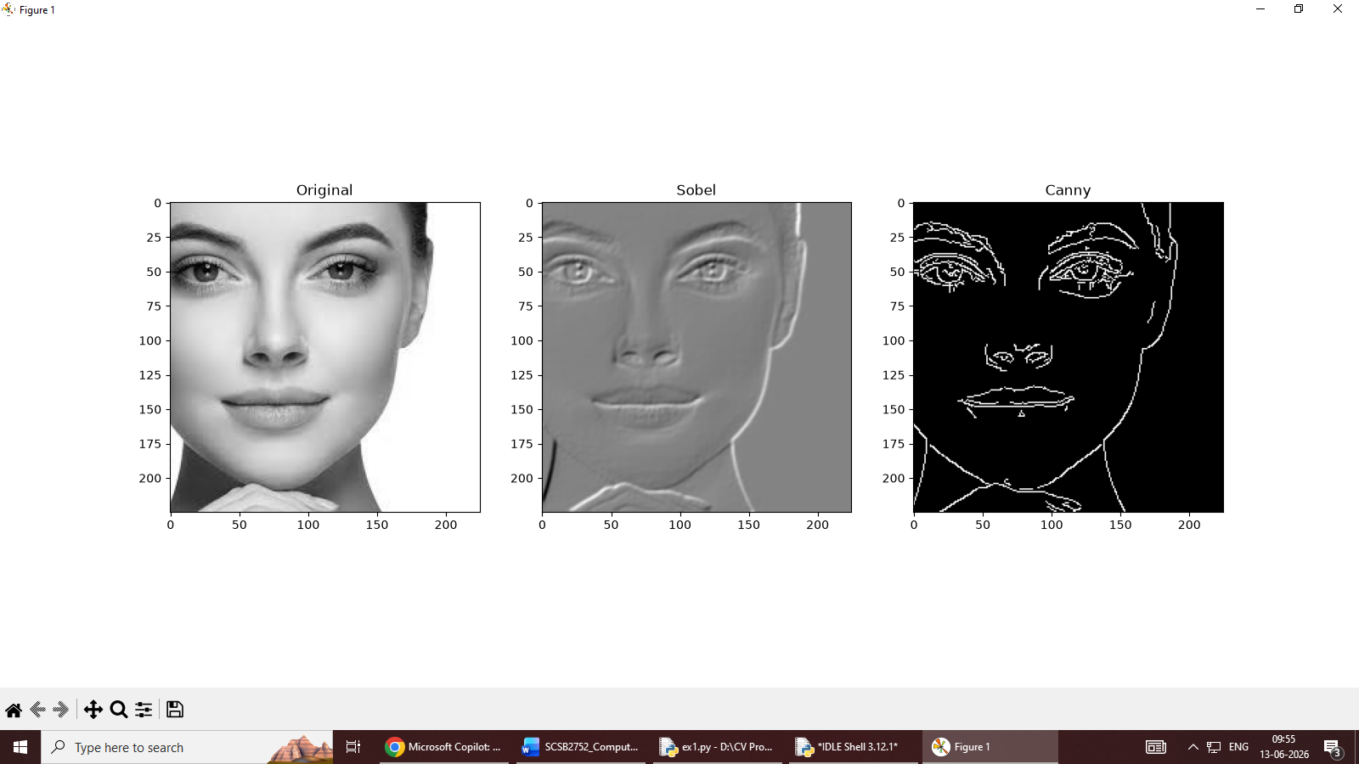

Result:
Thus, Edge Detection was successfully implemented using Sobel and Canny Operators in OpenCV.

Experiment 9: Shape Detection using Hough Transform
Aim
To study and implement shape detection using Hough Transform.
Algorithm
- Load the input image.
- Convert to grayscale and apply blur.
- Perform edge detection.
- Apply Hough Line Transform.
- Apply Hough Circle Transform.
- Display detected shapes.

Program:
import cv2
import numpy as np
def detect_shapes(image_path):
# Load the image
image = cv2.imread(image_path)
if image is None:
print(f"Error: Failed to load image from {image_path}.")
return
# Convert the image to grayscale
gray = cv2.cvtColor(image, cv2.COLOR_BGR2GRAY)
# Blur to reduce noise
gray_blurred = cv2.medianBlur(gray, 5)
# Edge detection
edges = cv2.Canny(gray, 50, 150, apertureSize=3)
# Hough Line Transform
lines = cv2.HoughLines(edges, 1, np.pi / 180, 150)
if lines is not None:
for rho, theta in lines[:, 0]:
a = np.cos(theta)
b = np.sin(theta)
x0 = a * rho
y0 = b * rho
x1 = int(x0 + 1000 * (-b))
y1 = int(y0 + 1000 * (a))
x2 = int(x0 - 1000 * (-b))
y2 = int(y0 - 1000 * (a))
cv2.line(image, (x1, y1), (x2, y2), (0, 0, 255), 2)
# Hough Circle Transform
circles = cv2.HoughCircles(gray_blurred, cv2.HOUGH_GRADIENT, 1, 20,
param1=50, param2=30, minRadius=1, maxRadius=40)
if circles is not None:
circles = np.uint16(np.around(circles))
for i in circles[0, :]:
cv2.circle(image, (i[0], i[1]), i[2], (0, 255, 0), 2)
cv2.circle(image, (i[0], i[1]), 2, (0, 0, 255), 3)
# Contour Detection for Other Shapes
contours, _ = cv2.findContours(edges, cv2.RETR_TREE, cv2.CHAIN_APPROX_SIMPLE)
for contour in contours:
# Approximate the contour
epsilon = 0.02 * cv2.arcLength(contour, True)
approx = cv2.approxPolyDP(contour, epsilon, True)
# Draw the contours for different shapes
if len(approx) == 3:
# Triangle
cv2.drawContours(image, [approx], 0, (0, 255, 255), 2)
elif len(approx) == 4:
# Rectangle or Square
cv2.drawContours(image, [approx], 0, (255, 0, 0), 2)
elif len(approx) > 4:
# Circle or Ellipse
area = cv2.contourArea(contour)
if area > 100:
cv2.drawContours(image, [approx], 0, (255, 255, 0), 2)
# Display the result
cv2.imshow('Shape Detection', image)
cv2.waitKey(0)
cv2.destroyAllWindows()
# Example usage
detect_shapes("C:\\Users\\student\\Downloads\\circle.png")

Input:
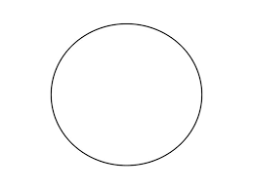

Output:

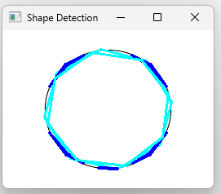

Result:
Thus, shape detection was successfully implemented using the Hough Transform in OpenCV

Experiment 10: Face Detection using Haar Cascade Classifier

Aim

To study and implement shape detection using Hough Transform.

Algorithm

Load the input image.

Convert to grayscale and apply blur.

Perform edge detection.

Apply Hough Line Transform.

Apply Hough Circle Transform.

Display detected shapes.

Program
import cv2
import matplotlib.pyplot as plt
image_path = 'C:/Users/student/Downloads/perfect-family-photo-session-by-rebecca-danzenbaker.webp' # Replace with your image path
image = cv2.imread(image_path)
if image is None:
print(f"Error: Could not load image from {image_path}")
else:
gray = cv2.cvtColor(image, cv2.COLOR_BGR2GRAY)
face_cascade = cv2.CascadeClassifier(cv2.data.haarcascades +
'haarcascade_frontalface_default.xml')
faces = face_cascade.detectMultiScale(gray, scaleFactor=1.1,
minNeighbors=5, minSize=(30, 30))
for (x, y, w, h) in faces:
cv2.rectangle(image, (x, y), (x+w, y+h), (255, 0, 0), 2)
image_rgb = cv2.cvtColor(image, cv2.COLOR_BGR2RGB)
plt.imshow(image_rgb)
plt.axis('off')
plt.show()
Output:

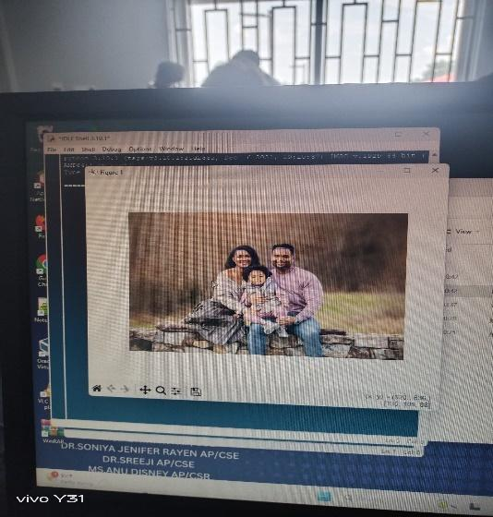

Result
Thus, face detection was successfully implemented using Haar Cascade Classifier in OpenCV.

Experiment 11: Scene Text Detection using OCR (Tesseract)

Aim

To study and implement scene text detection using Optical Character Recognition (OCR) with the Tesseract engine in OpenCV.

Algorithm
- Install and configure Tesseract OCR.
- Load the input image.
- Convert the image to grayscale for preprocessing.
- Apply OCR using pytesseract.image_to_string() to extract text.
- Display or store the recognized text for further use.
Requirements:
Install tessearct OCR from the link: https://github.com/UBMannheim/tesseract/releases/download/v5.4.0.20240606/tesseract-ocr-w64-setup5.4.0.20240606.exe
Code:
!pip install opencv-python pytesseract
import cv2
import pytesseract
pytesseract.pytesseract.tesseract_cmd =
'c:\\Users\\online\\AppData\\Local\\Programs\\Tesseract-OCR\\tesseract.exe'
def extract_text_from_image(image_path):
image = cv2.imread(image_path)
gray = cv2.cvtColor(image, cv2.COLOR_BGR2GRAY)
text = pytesseract.image_to_string(gray)
return text
image_path = './sample.jpeg'
extracted_text = extract_text_from_image(image_path)
print("Extracted Text:")
print(extracted_text)
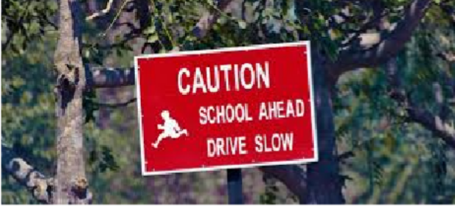
Input:

Output:
Extracted Text: CAUTION SCHOOL AHEAD DRIVE SLOW
Result

Thus, scene text detection was successfully implemented using Tesseract OCR in OpenCV.

Experiment 12: Road Lane Detection for Autonomous Vehicles

Aim

To study and implement road lane detection for autonomous vehicles using OpenCV.

Algorithm

Load the input video or image.

Convert the frame to grayscale.

Apply Gaussian blur to reduce noise.

Perform Canny edge detection.

Define a region of interest (ROI) to mask irrelevant areas.

Apply Hough Line Transform to detect lane lines.

Overlay detected lines on the original frame.

Display the processed video with lane markings.

Output:
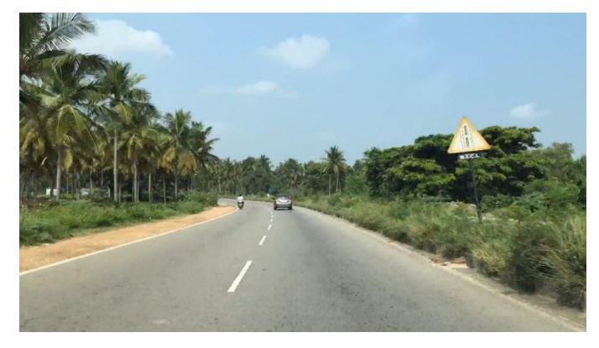
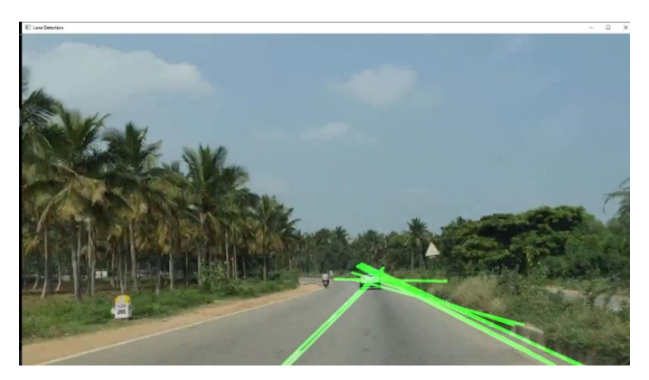

Result
Thus, road lane detection was successfully implemented using OpenCV.

Experiment 13: Emotion Recognition using DeepFace

Aim

To study and implement emotion recognition from facial images using the DeepFace library in Python.

Algorithm
- Install and import the DeepFace library.
- Load the input image containing a face.
- Call DeepFace.analyze() with the image path and specify actions=['emotion'].
- The model processes the image using pre-trained deep learning networks.
- Extract the predicted emotion and confidence scores.
- Display the recognized emotion as output.

Program
pip install deepface
import cv2
import matplotlib.pyplot as plt from deepface import DeepFace
img = cv2.imread(r'/content/321.jpg') plt.imshow(img[:, :, : : -1]) plt.show()
result = DeepFace.analyze(img,
actions = ['emotion'])

print(result)

Output
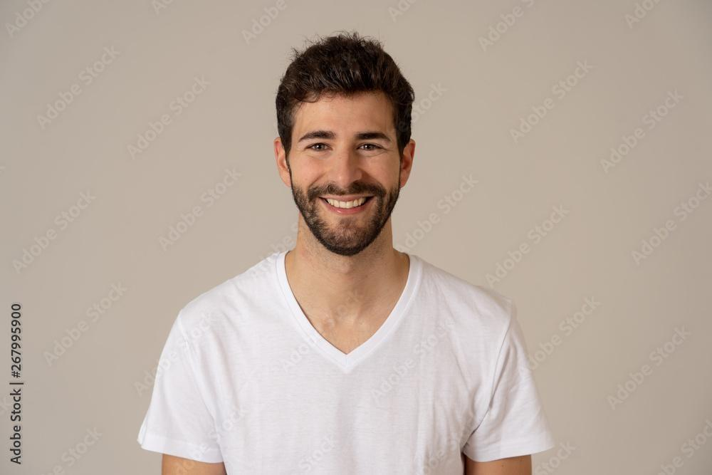

Output:
[{'emotion': {'angry': 3.441304430854275e-05, 'disgust': 2.3334745241022423e-08, 'fear': 1.6219297747606293e-06, 'happy':
96.60264890162362, 'sad': 0.0009235041752203513, 'surprise':
0.02197595633294209, 'neutral': 3.3744103909241687}, 'dominant_emotion':
'happy', 'region': {'x': 383, 'y': 123, 'w': 202, 'h': 202, 'left_eye': (515,
205), 'right_eye': (446, 206)}, 'face_confidence': 0.91}]

Result
Thus, emotion recognition was successfully implemented using DeepFace.

Experiment 14: Object Detection using YOLO

Aim

To study and implement object detection using the YOLO (You Only Look Once) deep learning algorithm in OpenCV.

Algorithm

Download YOLO configuration (.cfg) and pre-trained weights (.weights).

Load the YOLO model using OpenCV’s dnn module.

Read the input image or video.

Preprocess the frame (resize, normalize).

Pass the frame through the YOLO network.

Extract bounding boxes, confidence scores, and class IDs.

Apply Non-Maximum Suppression (NMS) to remove overlapping boxes.

Draw bounding boxes and labels on the detected objects.

Display the annotated output.

Program
import cv2
import numpy as np
# Load YOLO model
net = cv2.dnn.readNet("yolov3.weights", "yolov3.cfg")
layer_names = net.getLayerNames()
output_layers = [layer_names[i - 1] for i in net.getUnconnectedOutLayers()]
# Load COCO class labels
with open("coco.names", "r") as f:
classes = [line.strip() for line in f.readlines()]

# Load image
img = cv2.imread("test.jpg")
img = cv2.resize(img, None, fx=0.6, fy=0.6)
height, width, channels = img.shape
# Prepare input blob
blob = cv2.dnn.blobFromImage(img, 0.00392, (416, 416), (0, 0, 0), True, crop=False)
net.setInput(blob)
outs = net.forward(output_layers)
# Process detections
class_ids = []
confidences = []
boxes = []
for out in outs:
for detection in out:
scores = detection[5:]
class_id = np.argmax(scores)
confidence = scores[class_id]
if confidence > 0.5:
# Object detected
center_x = int(detection[0] * width)
center_y = int(detection[1] * height)
w = int(detection[2] * width)
h = int(detection[3] * height)

# Rectangle coordinates
x = int(center_x - w / 2)
y = int(center_y - h / 2)
boxes.append([x, y, w, h])
confidences.append(float(confidence))
class_ids.append(class_id)
# Apply Non-Maximum Suppression
indexes = cv2.dnn.NMSBoxes(boxes, confidences, 0.5, 0.4)
# Draw bounding boxes
font = cv2.FONT_HERSHEY_PLAIN
colors = np.random.uniform(0, 255, size=(len(classes), 3))
for i in range(len(boxes)):
if i in indexes:
x, y, w, h = boxes[i]
label = str(classes[class_ids[i]])
confidence = confidences[i]
color = colors[class_ids[i]]
cv2.rectangle(img, (x, y), (x + w, y + h), color, 2)
cv2.putText(img, f"{label} {round(confidence, 2)}", (x, y - 10), font, 1, color, 2)
# Show output
cv2.imshow("YOLO Object Detection", img)
cv2.waitKey(0)
cv2.destroyAllWindows()

Output

Result
Thus, object detection was successfully implemented using YOLO.

Experiment 15: Vehicle Counting in Images and Videos

Aim

To study and implement vehicle counting in images and video streams using OpenCV techniques such as background subtraction, contour detection, and object tracking.

Algorithm

Load the input image or video stream.

Convert frames to grayscale for preprocessing.

Apply Gaussian blur to reduce noise.

Use background subtraction (e.g., cv2.createBackgroundSubtractorMOG2) to detect moving objects.

Perform morphological operations to refine the detected regions.

Detect contours and filter them based on size to identify vehicles.

Define a counting line (ROI) across the frame.

Track vehicles crossing the line and increment the counter.

Display the processed video with bounding boxes and the vehicle count.

Program
import cv2
from pyzbar.pyzbar import decode
def decode_qr_from_image(image_path):
frame = cv2.imread(image_path)
if frame is None:
print(f"Failed to load image from {image_path}")
return
gray_frame = cv2.cvtColor(frame, cv2.COLOR_BGR2GRAY)
decoded_objects = decode(gray_frame)
for obj in decoded_objects:
qr_data = obj.data.decode('utf-8')
print('Data:', qr_data)
points = obj.polygon
if len(points) > 4:
hull = cv2.convexHull(np.array([point for point in points], dtype=np.float32))
hull = list(map(tuple, np.squeeze(hull)))
else:
hull = points
n = len(hull)
for j in range(0, n):
cv2.line(frame, hull[j], hull[(j + 1) % n], (255, 0, 0), 3)
cv2.imshow('QR Code Scanner', frame)
cv2.waitKey(0)
cv2.destroyAllWindows()
def main():
image_path = "C:\\Users\\student.SCASA1\\Downloads\\OIP.jpg" # Replace with your image path
decode_qr_from_image(image_path)
if __name__ == "__main__":
main()

Output

Result
Thus, vehicle counting was successfully implemented using OpenCV.
s

Experiment 16: QR Code Detection and Decoding

Aim

To study and implement QR code detection and decoding in images using OpenCV and the pyzbar library.

Algorithm

Import OpenCV and pyzbar libraries.

Load the input image or video.

Convert the frame to grayscale.

Use pyzbar.decode() to detect QR codes.

Extract bounding box coordinates and draw rectangles.

Decode the QR code data and display it.

Show the processed output with detected QR codes.

Program
import cv2
import numpy as np
from pyzbar.pyzbar import decode
from google.colab.patches import cv2_imshow
# Function to decode QR codes
def decode_qr(frame):
# Convert frame to grayscale
gray = cv2.cvtColor(frame, cv2.COLOR_BGR2GRAY)
# Decode QR codes
qr_codes = decode(gray)
return qr_codes

# Load the image file
image_path = 'qr.png' # Replace with your image path
frame = cv2.imread(image_path)

if frame is None:
print("Error: Could not read the image file")
exit()

# Detect QR codes
qr_codes = decode_qr(frame)

# Process detected QR codes
for qr_code in qr_codes:
# Extract QR code information
qr_data = qr_code.data.decode('utf-8')
# Draw bounding box around the QR code
points = qr_code.polygon
if len(points) > 4:
hull = cv2.convexHull(np.array([point for point in points],dtype = np.float32))
cv2.polylines(frame, [hull.astype(np.int32)], True, (255, 0, 0),3)
else:
cv2.polylines(frame, [np.array(points, dtype=np.int32)], True, (255, 0, 0), 3)

# Print QR code information
print("QR Code detected:", qr_data)

# Display the image with QR codes highlighted
cv2_imshow(frame)
cv2.waitKey(0)
cv2.destroyAllWindows()

Output
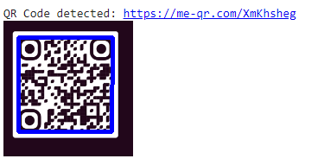

Result

Thus, QR code detection and decoding was successfully implemented using OpenCV and pyzbar.

